Technology Stack (Architecture & Stack)
Date | 19 September 2026
Team ID | SWTID-2026-6039
Project Name | AI WeatherWise API
Maximum Marks | 4 Marks

Technical Architecture:
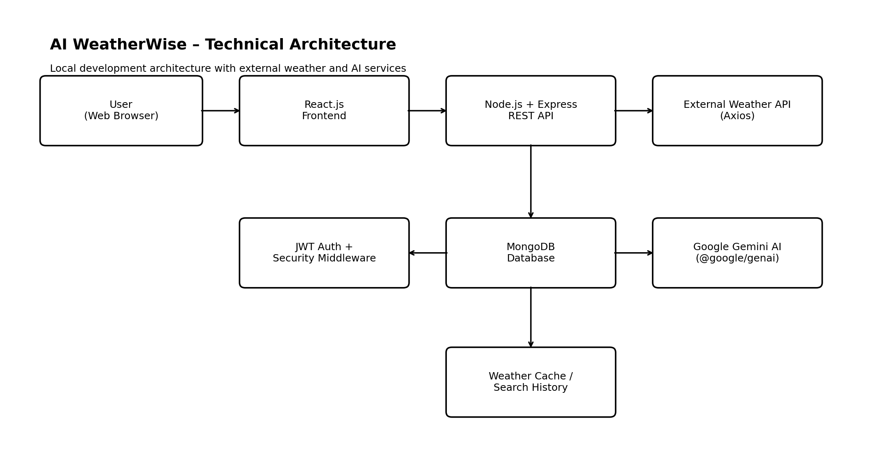
Architecture overview: The React.js frontend communicates with a Node.js/Express REST API. The backend manages authentication, weather requests, favorite locations and AI features. MongoDB stores users, locations, weather searches and cached data. Axios connects to an external weather API, while Google Gemini provides AI-generated weather summaries and recommendations.

Infrastructure: Local development uses the Node.js server on port 5000 and local MongoDB. External interfaces are the weather API and Google Gemini AI service. For production, the backend and database can be deployed using cloud hosting and MongoDB Atlas.

Table-1 : Components & Technologies:
S.No | Component | Description | Technology
1 | User Interface | Web interface for weather search, details, favorites and AI features. | React.js, HTML, CSS, JavaScript
2 | Application Logic-1 | REST API routes, authentication, locations and weather operations. | Node.js, Express.js
3 | Application Logic-2 | Request validation and API security controls. | express-validator, Helmet, CORS, express-rate-limit
4 | Application Logic-3 | AI weather summaries and recommendations. | Google Gemini API, @google/genai
5 | Database | Stores users, locations, searches and cached weather data. | MongoDB, Mongoose
6 | Cloud Database | Cloud database option for production deployment. | MongoDB Atlas
7 | File Storage | Project and configuration files; no dedicated user file storage. | Local Filesystem
8 | External API-1 | Fetches current weather information for cities. | Weather API via Axios
9 | External API-2 | Generates AI weather summaries and recommendations. | Google Gemini API
10 | Machine Learning Model | Generates natural-language weather insights. | Google Gemini AI model
11 | Infrastructure | Local Node.js server; deployable to cloud hosting. | Node.js + Cloud Hosting

Table-2: Application Characteristics:
S.No | Characteristics | Description | Technology
1 | Open-Source Frameworks | Open-source frontend, backend and database libraries. | React.js, Node.js, Express.js, Mongoose
2 | Security | Password hashing, JWT authentication, validation, security headers, CORS and rate limiting. | bcryptjs, jsonwebtoken, express-validator, Helmet, CORS, express-rate-limit
3 | Scalable Architecture | Separated frontend/backend with REST APIs and MongoDB. | React.js + Express.js + MongoDB
4 | Availability | Can use cloud hosting and managed database services for production. | Node.js + MongoDB Atlas
5 | Performance | Caching can reduce repeated weather API calls; rate limiting controls excess requests. | Axios + MongoDB Cache + express-rate-limit

